Information mail №2
Ministry of Education and Science of Ukraine
Kryvyi Rih State Pedagogical University
Bohdan Khmelnytsky National University of Cherkasy
Working group of Birds of Prey and Owl of Ukraine
Ukrainian Birds of Prey Research Centre
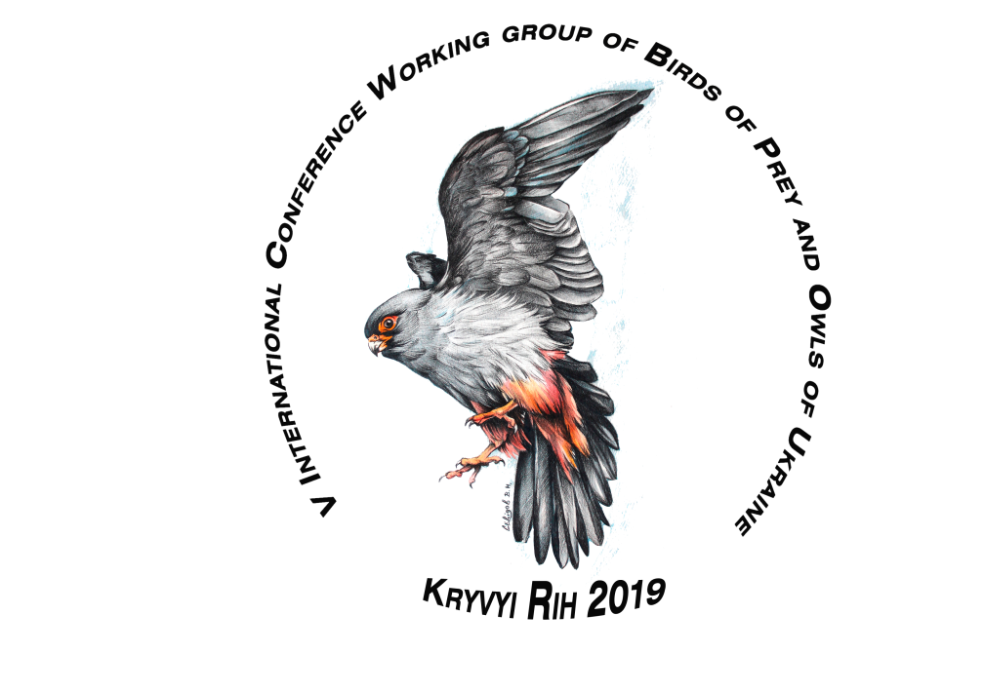
Iogotype – painter Sevidov V.

Dear Colleagues!
Working group of Birds of Prey and Owls of Ukraine invites you to participate in the 5th International Conference “Birds of Prey of Ukraine and surrounding territories”, which will be held on November 14-17, 2019 in Kryvyi Rih, on the basis of the Kryvyi Rih State Pedagogical University.

ORGANIZING COMMITTEE
Chairman – doctor Stryhunov V., Kryvyi Rih. (vi.strigunov@gmail.com)
With the chairman – doctor Gavryluk M., Cherkasy.
With the chairman – doctor Mylobog Y., Kryvyi Rih.
executive secretary Potopa A. ( potopaalina2708@gmail.com )
Members:
doc. Broshko Y., Kryvyi Rih.
doc. Rashevska H., Kryvyi Rih.
doc. Mytiai I., Kyiv.
doc. Ilucha O., Cherkasy.
doc. Bokotey A., Lviv.
doc. Atemasova T., Kharkiv.
doc. Chernichko R., Melitopol.
lecturer Kotsiuruba V., Kryvyi Rih.
lecturer Gerasemchuk O., Kryvyi Rih.
lecturer Yanchuk I., Kryvyi Rih.

Presentation types: oral report, poster presentation.
Official language: English, Ukrainian, Russian.
SECTIONS

- PALAEONTOLOGY, MORPOHOLOGY AND SYSTEMATICS
- DISTRIBUCION, NUMBERS AND POPULATION BIOLOGY
- MIGRATICIONS AND WINTERING BEHAVIOR
- PARASITES AND PREDATORS BIRD OF PREY AND PEOPLE
- MUSEUMS AND BIBLIOGRAPHIES

An abstracts digest of the Conference will be published before its beginning and posted electronically on the KDPU web-site. Deadline of abstract submission in July 30, 2019, registration continues.
Planned: excursion by technogenic landscapes of Kryvyi Rih, ornithological photo exhibition.
Accommodation in a student hostel or 3-star hotel.
Abstract guidelines
Title of the Study (12 pt, Times New Roman, Bold, Centered)
Author¹ (First Name SURNAME), Author², Author³, ...... (11 pt, Times New Roman, Centered, Presenter’s name will be underlined)
¹Department/Research Institute, University, Country, (10 pt, Times New Roman, Centered)
²Department/Research Institute, University, Country (10 pt, Times New Roman, Centered)
³Department/Research Institute, University, Country (10 pt, Times New Roman , Centered)
(aaa@xxxx.com) Email of the corresponding author

Introduction: This section must describe the main objective of the current study (11,5 pt, Times New Roman l, Justified)
Material and Methods: This section must describe material and methods used in the current study (11,5 pt, Times New Roman , Justified)
Results: This section must describe the main results of the current study (11,5 pt, Times New Roman, Justified)
Discussion: This section must describe the main idea of performing the study in question. (11,5 pt, Times New Roman, Justified)
Acknowledgements: This section must describe financial supports (as organization, institute, project number) and the persons who contribute the current study. No reference/bibliography will be given (11,5 pt, Times New Roman, Justified).
Keywords: keyword 1, keyword 2, etc. (11,5 pt, Times New Roman , Justified)

ABSTRACT MUST NOT EXCEED ONE PAGE

